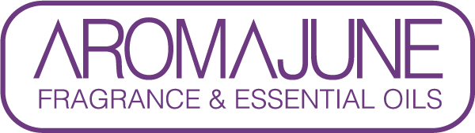

DATE : {{DATE}}
TO : {{CUSTOMER}}
SUBJCET : METHYL SALICYLATE CERTIFICATE
PRODUCT NAME : {{PRODUCT}}

AROMAJUNE hereby certifies that this fragrance material does not contain Methyl salicylate(CAS No. 119-36-8).



